Return to school - Tuesday 9th June
Please bring these items back to school on Tuesday the 9th June.
- Pencil case/water bottle
- Textbooks (English and Maths)

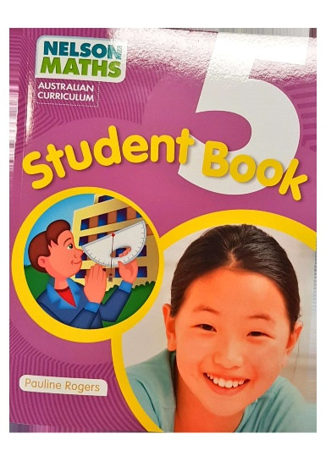

- Home Learning work book 1 and 2
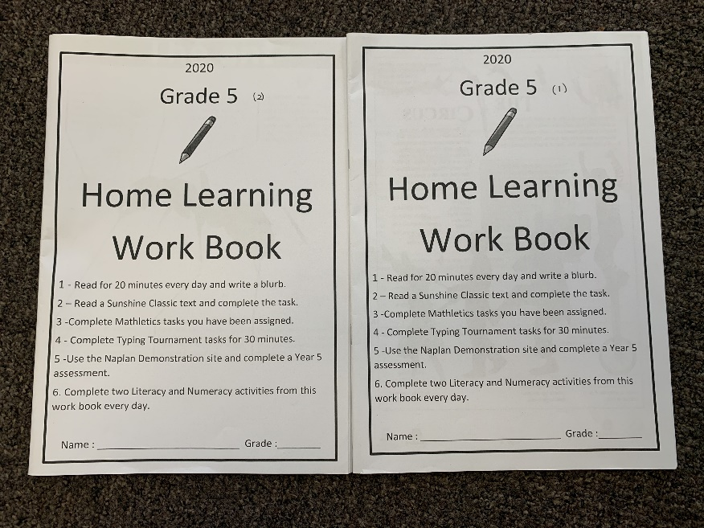

- Numeracy and Literacy exercise books

Monday the 1st June, 2020

Literacy

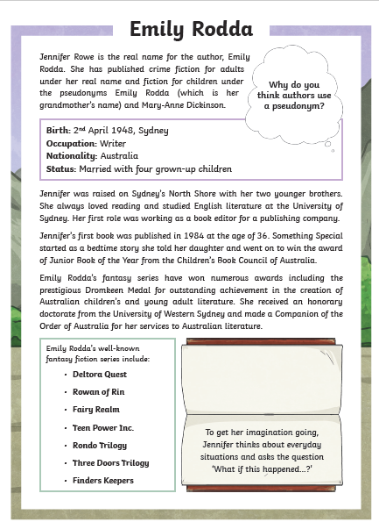

Higher order thinking Questions

Learning Intention :
Literacy
We are learning to read and understand a non-fiction text and use reading comprehension strategies to answers questions.
History
We are learning to identify the contributions individuals have had to our society
Success Criteria :
- I can successfully use evidence from the text to answer questions.
- I can use a timeline to sequence the events in the text.

Questions

Remembering
- What happened in the year 1984.
- What was her first working role as a young girl?

Understanding

- Where do you think Emily Rodda's love for children's books began?
- What can you conclude about this author?

Analysing

- What is the main idea and supporting details of this biographical recount.
- What relationship exists between Emily Rodda and Jennifer Rowe?

Evaluative

- What do you think about the author's choice of text features in this Biographical recount? Explain how they support or possibly do not support the intended information?

Writing
In Writing today you will re-read the Biography about Cathy Freeman from last week's lesson. Please look carefully at the circumstances of time and place the important events in the vertical time line below. Please make sure the you carefully look at the dates and place them in the correct sequence and the important event.

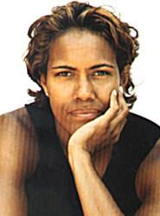

Biography
Cathy Freeman was born in Mackay, Queensland in 1973. From the time Freeman was a child she dreamed of winning an Olympic gold medal. She raced for the first time when she was eight years old. She ran the 80 metre sprint at her primary school and won easily.
Freeman has achieved much more than her dream of Olympic Gold. She won a scholarship to two Queensland schools, Fairholme College and Kooralbyn International School. At Kooralbyn in 1989 she was professionally coached for the first time.
In 1990 Freeman competed in her first Commonwealth games where she won gold as a member of the 4 x 100 metres relay team. She became the first Aboriginal sprinter to win a gold medal at the Commonwealth Games. At the 1994 Commonwealth Games she won the 200 and 400 metre gold medals. The 1992 Barcelona Olympics were her first Olympics but she did not make the finals. At the 1996 Atlanta Olympics, Freeman won a silver medal. In 1990 she was chosen as the Young Australian of the Year and in 1998 Australian of the Year. She is the first person to receive both awards.
Freeman was given the honour of lighting the Olympic flame at the opening ceremony of the 2000 Sydney Olympics. At those Olympics with the hopes of the nation running with her she fulfilled her childhood dream winning gold for the 400 metres. After the race she sat on the track emotionally and physically exhausted. The crowd wildly cheered her on her victory lap as she proudly carried the Australian and Aboriginal flags as she had first done at the 1994 Commonwealth Games.
Freeman has now retired from professional running and devotes much of her time and energy to important causes, particularly Aboriginal issues.

Time line

Time | Event
1973 | Cathy Freeman was born in Queensland.

Numeracy

Today you will be working on Data representation and graphs.

Please look carefully at the data on the graphs and answer the questions in your Maths book. Please make sure that you write the type of graph and the question numbers underneath it.

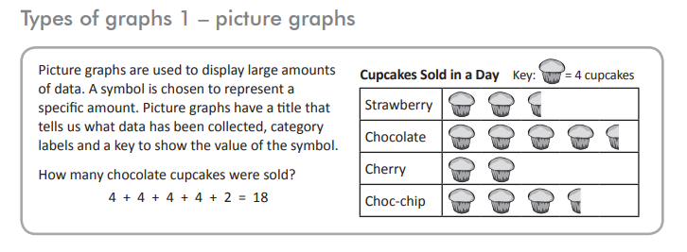

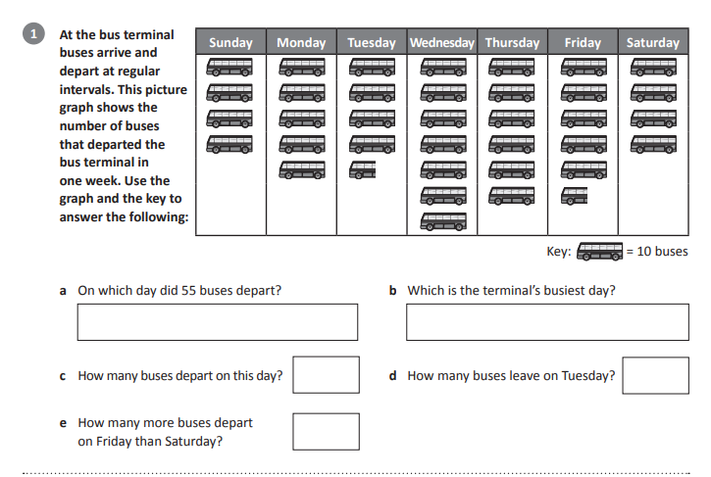

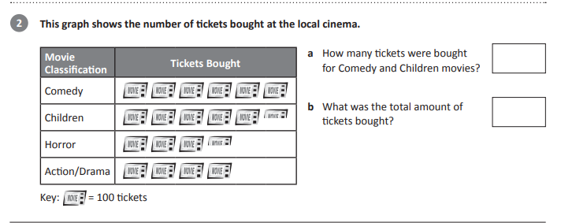

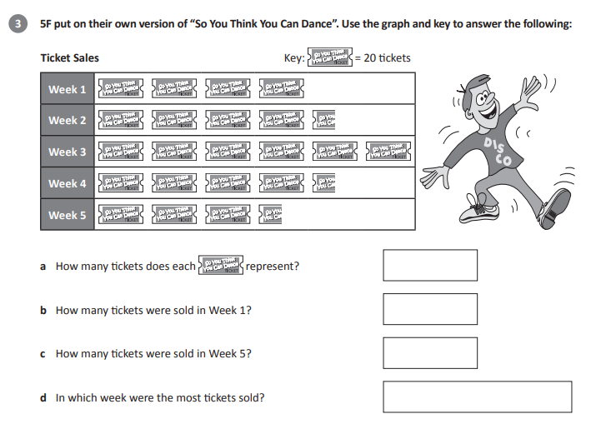

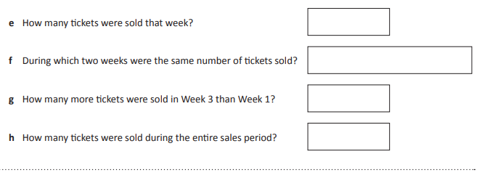

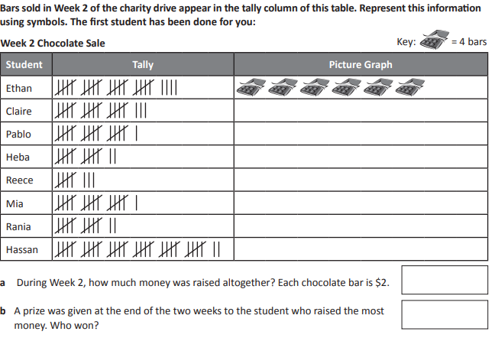
Another way to show data is in a column graph. Today we will be looking at how data can be represented in a column graph.

Please read the information below on column graphs.

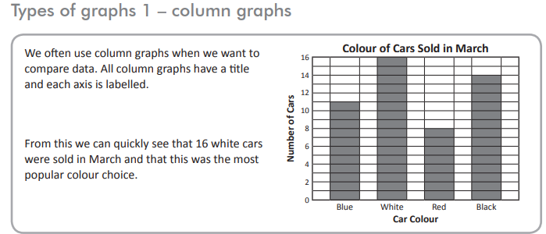

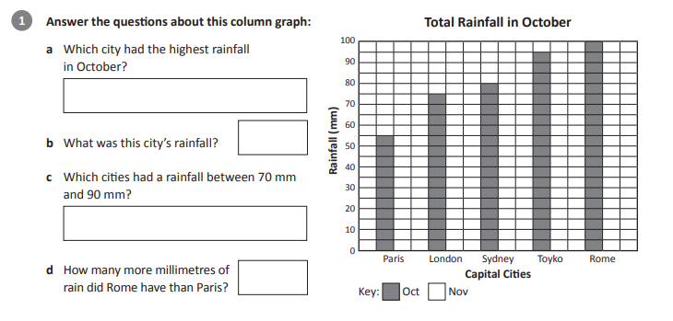

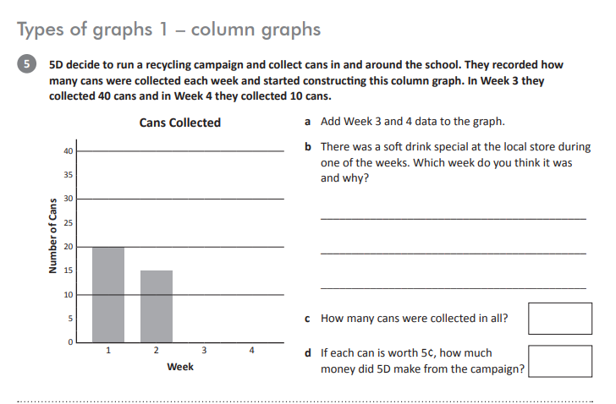

Afternoon Activities - Science
Please continue on with your Science projects.

Tuesday 2nd June, 2020
Literacy
Compare and Contrast activity
Today we will be looking at the Roald Dahl and the Emily Rodda biographical recounts. You will need to use the Venn Diagram below to compare and contrast the two texts.

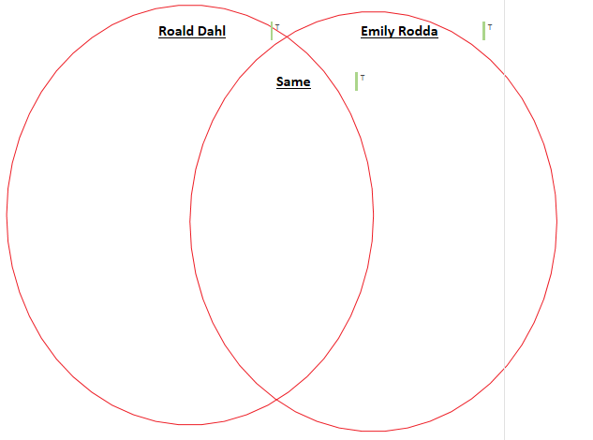
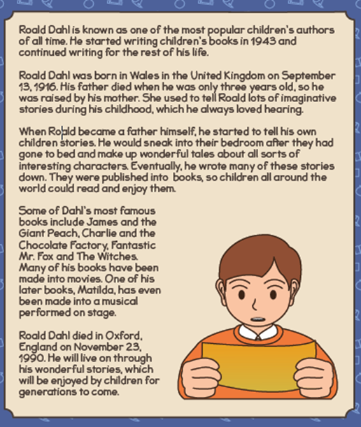

Writing
Student Remote Learning Reflection

Today you will be writing a reflective paragraph about your remote learning with no more than 450 characters (about 4 sentences). This paragraph will need to be drafted, edited and uplevelled, with the published paragraph written in your Writing book. This paragraph will be used in your report to reflect on your online and remote learning at home.

These are the questions you will be answering in your paragraph:
What have you enjoyed about online and remote learning?
What challenge did you face while learning remotely and online?
How did you feel about remote learning?

Use these sentence starters to help with your writing:
During remote and online learning I have enjoyed…
A challenge I faced…
I felt…
The work that I am the most proudest of is......

Numeracy

Another way to show data is in a pie graph. Today we will be looking at how data can be represented in a pie graph.

Please read the information below on what a pie graph is.
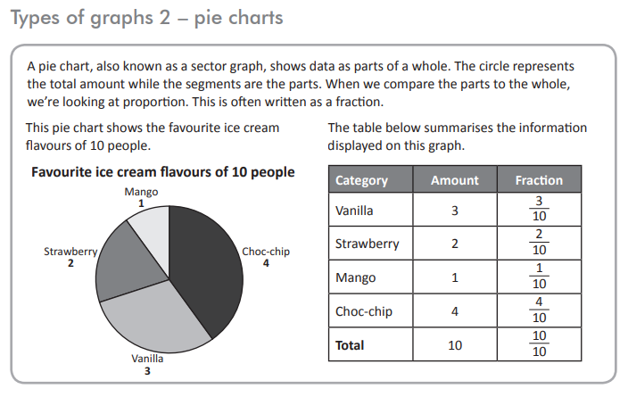
Please look carefully at the data on the pie graphs and answer the questions in your Maths book. Please make sure that you write the question numbers.

1)

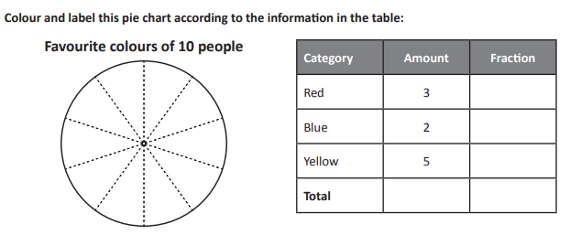

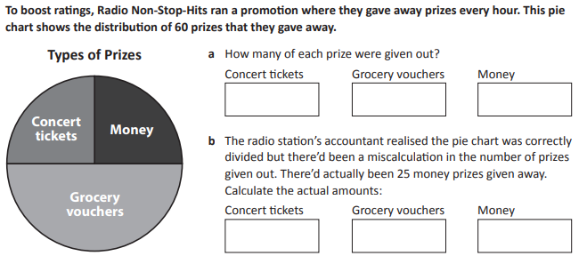

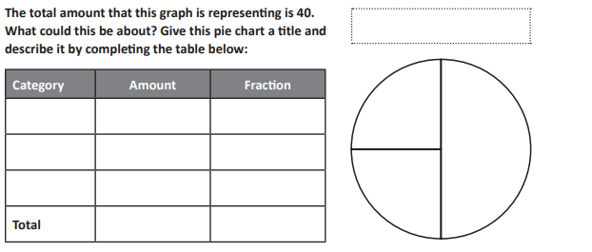

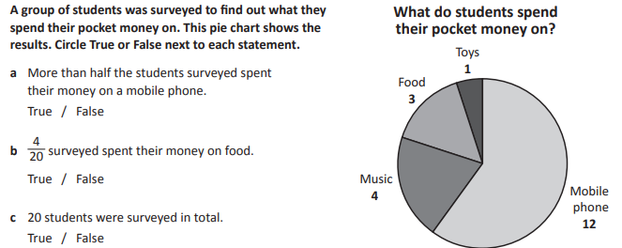

Another way to show data is in a line graph. Today we will be looking at how data can be represented in a line graph.

Please read the information below on line graphs.

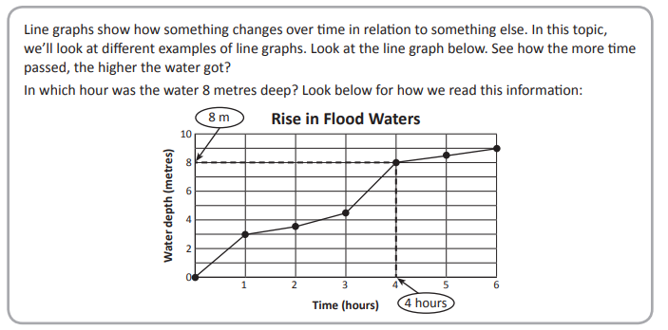

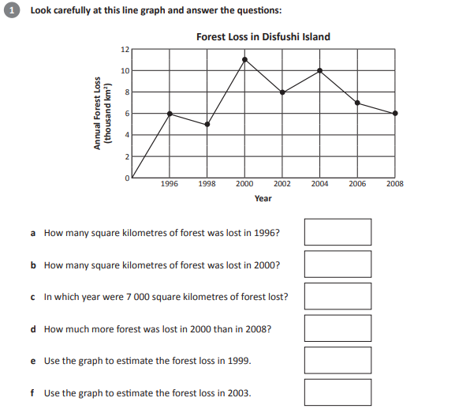

2)
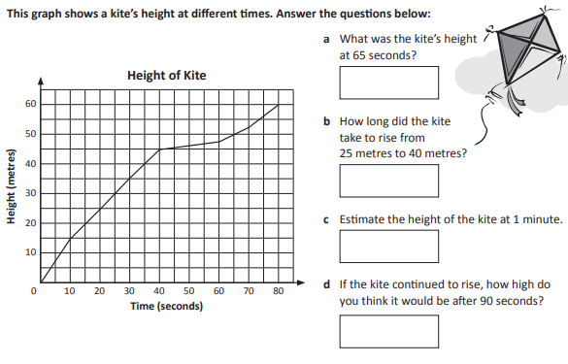
3)
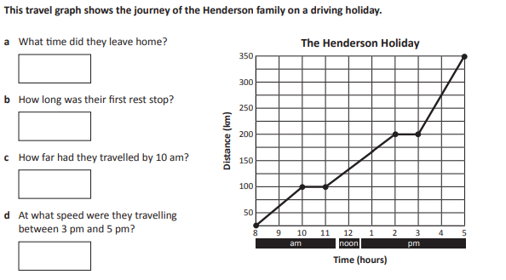
Afternoon Activities - Indonesian
This afternoon spend some time working on your INDONESIAN LANGUAGE tasks.

Literacy
Wednesday 3rd June, 2020
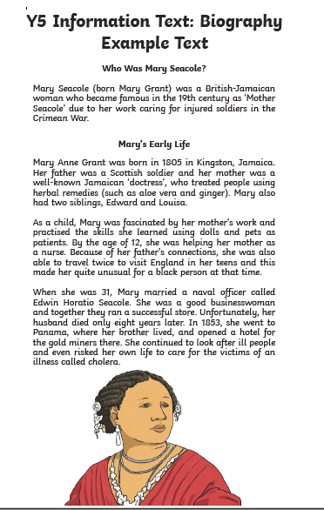

Flow Chart

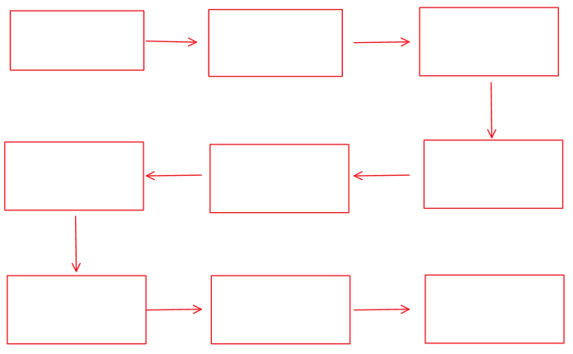

Writing

Today in Writing you will be identifying the coordinating and subordinating conjunctions in the modelled text Elizabeth Macarthur. Please refer to the VCOP wall under the heading C for Connectives. Here you will see the different types of coordinating and subordinating conjunctions which form compound and complex sentences. Highlight the different types of conjunctions using a pink highlighter.

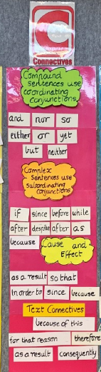

Biography
Cathy Freeman was born in Mackay, Queensland in 1973. From the time Freeman was a child she dreamed of winning an Olympic gold medal. She raced for the first time when she was eight years old. She ran the 80 metre sprint at her primary school and won easily.
Freeman has achieved much more than her dream of Olympic Gold. She won a scholarship to two Queensland schools, Fairholme College and Kooralbyn International School. At Kooralbyn in 1989 she was professionally coached for the first time.
In 1990 Freeman competed in her first Commonwealth games where she won gold as a member of the 4 x 100 metres relay team. She became the first Aboriginal sprinter to win a gold medal at the Commonwealth Games. At the 1994 Commonwealth Games she won the 200 and 400 metre gold medals. The 1992 Barcelona Olympics were her first Olympics but she did not make the finals. At the 1996 Atlanta Olympics, Freeman won a silver medal. In 1990 she was chosen as the Young Australian of the Year and in 1998 Australian of the Year. She is the first person to receive both awards.
Freeman was given the honour of lighting the Olympic flame at the opening ceremony of the 2000 Sydney Olympics. At those Olympics with the hopes of the nation running with her she fulfilled her childhood dream winning gold for the 400 metres. After the race she sat on the track emotionally and physically exhausted. The crowd wildly cheered her on her victory lap as she proudly carried the Australian and Aboriginal flags as she had first done at the 1994 Commonwealth Games.
Freeman has now retired from professional running and devotes much of her time and energy to important causes, particularly Aboriginal issues.

Simple sentences | Compound Sentences ( and, but, so ,nor, or, yet )

Numeracy:
Today you will be looking at column graphs on page 116 of your Maths Student Book.
Use the data in the table to create your graph. Make sure you have labelled your graph.
Once you have completed the work, take a photo and post it on new page in your Numeracy folder.
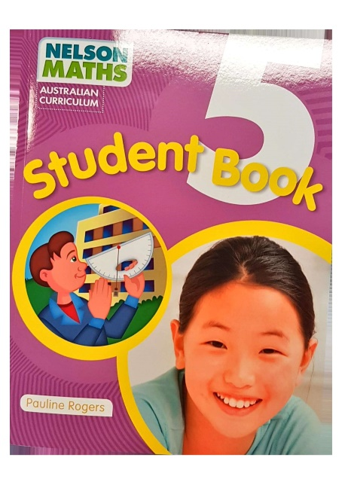

Spelling :
Sound Waves Unit 8
Today you will be logging onto the Soundwaves website to complete an activity.
Click onto Unit 8 (f ff ph - fish cliff phone ) . You will need to scroll down and complete the Grapheme Trek and the Unjumbler activities. Please logon to this website and type in this code.
www.soundwaveskids.com.au please enter the code purple923

When you have finished this please complete questions 4,5, 6 and 7 of Unit 8 (f ff ph - fish cliff phone) in your Soundwaves book.
Don't forget to use a dictionary or research www.etymonline.com

Afternoon Activities - PE
Complete the set tasks for Physical Education. Use this week to catch up on any tasks you have not completed yet and to revise over your learning.

Thursday 4th June, 2020
Literacy

Summarising

In Reading today, you will be summarising the text 'Who was Mary Seacole'

Use a highlighter to highlight 15-20 keywords from the text. Use these keywords to write a summary about Mary Seacole. Your paragraph should consist of no more than 50-60 words.

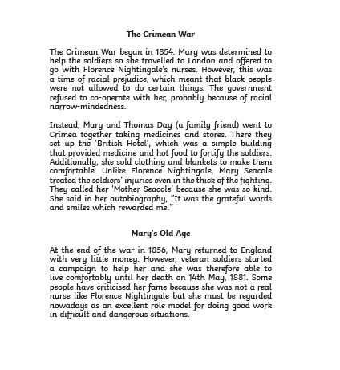
Writing

Proper noun and Common noun Word hunt

You will highlight the Proper nouns in yellow and the Common nouns in blue.

Biography
Cathy Freeman was born in Mackay, Queensland in 1973. From the time Freeman was a child she dreamed of winning an Olympic gold medal. She raced for the first time when she was eight years old. She ran the 80 metre sprint at her primary school and won easily.
Freeman has achieved much more than her dream of Olympic Gold. She won a scholarship to two Queensland schools, Fairholme College and Kooralbyn International School. At Kooralbyn in 1989 she was professionally coached for the first time.
In 1990 Freeman competed in her first Commonwealth games where she won gold as a member of the 4 x 100 metres relay team. She became the first Aboriginal sprinter to win a gold medal at the Commonwealth Games. At the 1994 Commonwealth Games she won the 200 and 400 metre gold medals. The 1992 Barcelona Olympics were her first Olympics but she did not make the finals. At the 1996 Atlanta Olympics, Freeman won a silver medal. In 1990 she was chosen as the Young Australian of the Year and in 1998 Australian of the Year. She is the first person to receive both awards.
Freeman was given the honour of lighting the Olympic flame at the opening ceremony of the 2000 Sydney Olympics. At those Olympics with the hopes of the nation running with her she fulfilled her childhood dream winning gold for the 400 metres. After the race she sat on the track emotionally and physically exhausted. The crowd wildly cheered her on her victory lap as she proudly carried the Australian and Aboriginal flags as she had first done at the 1994 Commonwealth Games.
Freeman has now retired from professional running and devotes much of her time and energy to important causes, particularly Aboriginal issues.

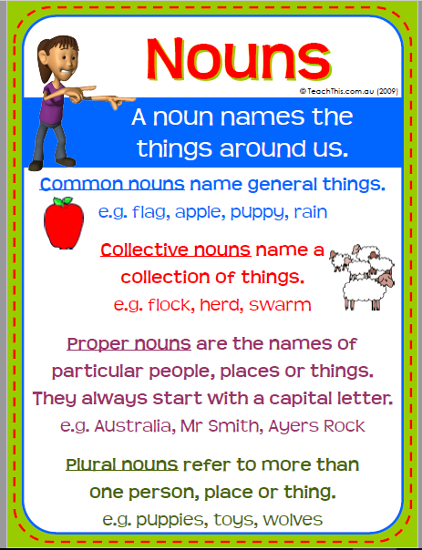

Proper Nouns | Common Nouns

Spelling
Complete Sound Waves Unit 8
Today you will be logging onto the Soundwaves website to complete an activity.
Click onto Unit 8 (f ff ph - fish cliff phone ) . You will need to scroll down and complete the List Word Beginnings and Endings activity and the Grapheme Sort. Please logon to this website and type in this code.
www.soundwaveskids.com.au please enter the code purple923

Then complete Unit 8 (f ff ph - fish cliff phone ) in your Soundwaves book.
Complete question 8, 9, 10 and the challenge.
Don't forget to use a dictionary or research www.etymonline.com
. You will need to scroll down and complete the List Word Beginnings and Endings activity and the Grapheme Sort. Please logon to this website and type in this code.
www.soundwaveskids.com.au please enter the code purple923

Numeracy

Today you will be working from your Numeracy book and complete page 117. You will need to use the data below, complete the table and choose an appropriate graph to present it. Think about the graphs you have completed over the last few days, you could do a column graph, pie graph, picture graph or a line graph.

Category | Number of People | Fraction
Chicken | 60
Ham | 15
Beef | 25
Total | 100 | 100/100

Afternoon Activities - STEM
Log on to code.org and complete tasks from this website.

Friday 5th June, 2020
Literacy

Fact and Opinion

Please reread the Biographical Recount about Mary Seacole and list the facts and opinions in the table below.
What is a fact? A fact is something that can be checked and back dup with evidence. For example, there are 26 known asteroids located in the asteroid belt. We can check these details by looking at NASA records. Facts are often used in conjunction with research and study.
What is an opinion? An opinion is based on a belief or view. It is based on evidence that can be checked. For example, Katy Perry is the best singer ever. Some people might think there are other singers who are better than Katy Perry. Opinions can be found in many types of writing such as, letters to the editor, in a newspaper or in online forums or social media sights.

FACTS | OPINIONS

Writing

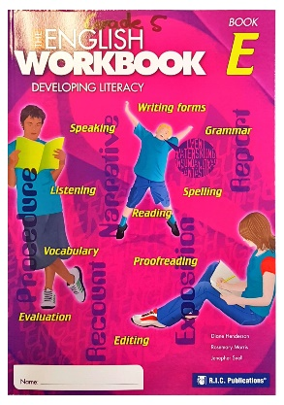

Today in Writing you will be focusing on the language features from 'Water skiing at Point Watson' page 102. You will be completing the langauge features activities from pages 111, 112 and 113.

Sound Waves - Unit 8 Corrections
View the answers of the Unit to see how you went this week. Always remember to correct in a red pen or pencil and write down the correct answers (in red) if an error is made. Good luck!

Numeracy
Today you are going to create a picture graph. Use the information below to help you.
Cindy counted 48 balloons that were sold at a fair.
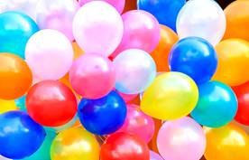
Of these, 10 were green, 14 were blue, 12 were red, 4 were yellow, and the rest were orange.
Part A
The most popular choice was:
The least popular choice was:
Part B
Construct a picture graph to show this data.
You need to choose an appropriate key for the data
- An appropriate key for this data is that 1 picture represents ? balloons
Remember to label the graph and give it a title.

Afternoon Activities - Library
This afternoon please complete the library tasks set. Please catch up on any in completed tasks and revise over the learning.

